July 9th, 2006
Hi
I have fewer entries in my diary this week so the letter will probably be shorter.
Last Monday, the government's implementation of a five-day working week for civil servants began. Some government offices will therefore be closed on Saturdays. The scheme will gradually be extended until most civil servants are included, except those involved in emergency and essential services. The other day, the HSBC announced that it too will implement a five-day week, so many branches will be closed on Saturdays.
Last Monday, I began swimming again following the operation. Had three swims for the week, doing a total of 3.6 km. The water did not seem to have any adverse effect on the skin grafts. I am now going to go to the pool late in the afternoons when the UV Index is low. However, the pool can be more crowded at this time. On Friday, there were 34 people in the pool when I finished. The water was also very hot at 34⁰C, the hottest I have ever experienced it at this pool. (The Chinese University pool regularly used to reach 33-34⁰C!) It is certainly tiring swimming in such hot water. For a third ‘34’, my time for this swim was about 34 min!
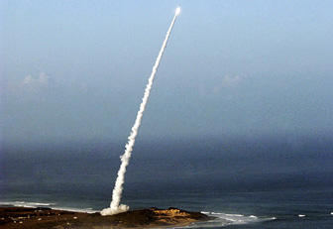
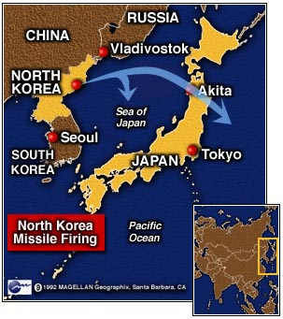
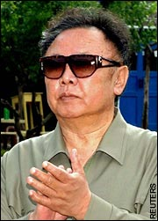
You have probably heard that North Korea test fired several missiles this past week. One long-range missile malfunctioned and landed in the Sea of Japan; had it not done so, its trajectory would have taken it to near Hawaii! One of the pictures below shows a rocket a few seconds after launch. This was on a Washington Times website, though how they got such a photo I do not know (unless it is from an earlier test).
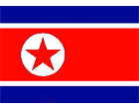

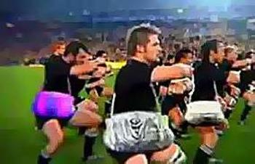
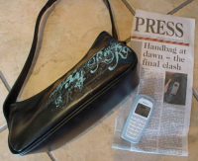
TVB news the other night showed an advertisement shown on Australian TV in the past few days and has been causing quite a stir. The ad has the “All Black handbag haka” and was designed to promote the first tri-nations match between Australia and NZ on Saturday. The ad shows the All Blacks performing a pre-game haka, with large, digitally enhanced women’s handbags slung over each of the players’ shoulders. To understand it, you have to go back to an incident a few weeks ago following the final of the Super 14 competition in Christchurch. After their loss, some of the Wellington Hurricanes players were in a pub. One of the players, somewhat drunk, tripped over another patron’s foot, then turned and punched this patron. To ward off trouble, Tana Umaga, the captain (who has also just retired as All Black captain), belted his teammate twice over the head with a woman’s handbag he picked up off a table as if to say “You idiot!” This left the burly 106 kg player in tears. The offending handbag later attracted about US$14 000 in an online auction. The ad is poking fun at this incident. I was also reading somewhere that there was another ad showing Umaga charging down a pitch holding a handbag instead of a ball! The photographs below show a picture from the advertisement video and also the handbag (and the mobile phone, which was in the handbag and was damaged).
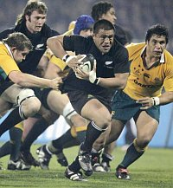
I watched the NZ-Australia test live on TV. The ABs began with their new ‘throat-slitting’ haka. This is just the third time it has been used. I like it! There is no big jump into the air at the end. Read the words (in English) for the new haka. They refer specifically to the All Blacks (see below) whereas the original ‘Ka Mate’ haka (words also below) is a warrior war haka which was not written with the All Blacks in mind. The throat-slitting action in Maori symbolism actually has nothing to do with that. It was a good game which NZ won 32 – 12 though the game was closer than the score indicated. About 12 minutes before the end of the first half, an Australian player was sin-binned’ (which is a mandatory 10 minutes) during which NZ got two converted tries (14 points) having been down 7 points.
That seems to be it for now. Well, a bit more than I thought!

Cheers

Kapa O Pango
 | Kapa O Pango kia whakawhenua au i ahau! |  | All Blacks, let me become one with the land
 | Hī aue, hī!
 | Ko Aotearoa e ngunguru nei! |  | This is our land that rumbles
 | Au, au, aue hā! |  | It’s my time! It’s my moment!
 | Ko Kapa O Pango e ngunguru nei! |  | This defines us as the All Blacks
 | Au, au, aue hā! |  | It’s my time! It’s my moment!
 | I āhahā!
 | Ka tū te ihiihi |  | Our dominance
 | Ka tū te wanawana |  | Our supremacy will triumph
 | Ki runga ki te rangi e tū iho nei, tū iho nei, hī! |  | And be placed on high
 | Ponga rā! |  | Silver fern!
 | Kapa O Pango, aue hī! |  | All Blacks!
 | Ponga rā! |  | Silver fern!
 | Kapa O Pango, aue hī, hā! |  | All Blacks!

Ka Mate
Leader: | Ringa pakia! |  | Slap the hands against the thighs!
 | Uma tiraha! |  | Puff out the chest!
 | Turi whatia! |  | Bend the knees!
 | Hope whai ake! |  | Let the hip follow!
 | Waewae takahia kia kino! |  | Stamp the feet as hard as you can!
Leader: | Ka mate, ka mate |  | ’Tis death, ‘tis death (or: I may die)
Team: | Ka ora, ka ora |  | ’Tis life, ‘tis life (or: I may live)
Leader: | Ka mate, ka mate |  | ’Tis death, ‘tis death
Team: | Ka ora, ka ora |  | ’Tis life, ‘tis life
All: | Tēnei te tangata pūhuruhuru |  | There is the man so hairy…
 | Nāna nei i tiki mai whakawhiti te rā |  | …who brought the sun and caused it to shine
 | Ā upane, ka upane |  | A step, another step
 | Ā upane, ka upane |  | A step, another step
 | Whiti te rā, hī! |  | The sun shines!

